GDPR

The General Data Protection Regulation (GDPR) standardizes data protection law across all 28 EU countries and imposes strict new rules on controlling and processing personally identifiable information (PII). It also extends the protection of personal data and data protection rights by giving control back to EU residents. GDPR replaces the 1995 EU Data Protection Directive, and goes into force on May 25, 2018. It also supersedes the 1998 UK Data Protection act.

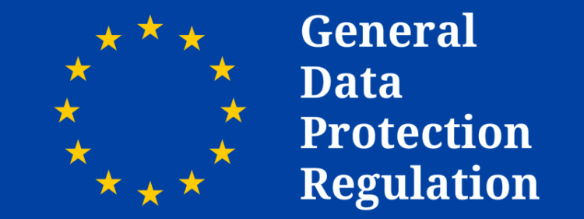

GDPR replaces the EU Data Protection Directive of 1995. The new directive focuses on keeping businesses more transparent and expanding the privacy rights of data subjects. When a serious data breach has been detected, the company is required by the General Data Protection Regulation to notify all affected people and the supervising authority within 72 hours. Mandates in the General Data Protection Regulation apply to all data produced by EU citizens, whether or not the company collecting the data in question is located within the EU, as well as all people whose data is stored within the EU, whether or not they are actually EU citizens.

Under GDPR, companies may not legally process any person's personally identifiable information without meeting at least one of six conditions.

1)Express consent of the data subject.

2)Processing is necessary for the performance of a contract with the data subject or to take steps to enter into a contract.

3)Processing is necessary for compliance with a legal obligation.

4)Processing is necessary to protect the vital interests of a data subject or another person.

5)Processing is necessary for the performance of a task carried out in the public interest or in the exercise of official authority vested in the controller.

6)Processing is necessary for the purposes of legitimate interests pursued by the controller or a third party, except where such interests are overridden by the interests, rights or freedoms of the data subject.